# Lesson 7 – Vertical and Hydrological Analysis

## Task Information

This lesson uses completely new data, which are not connected to the TUM study area. You will perform some vertical and hydrological analysis, as well as a least cost path analysis. This is done on a data set from an area around Germany´s highest mountain, the Zugspitze, south of Munich.

## Vertical Analysis

An ArcGIS Pro scene can be viewed in either global or local mode. In global mode, the earth is drawn as a globe and your viewpoint is usually thousands of kilometres from the data. This view is best for very large study areas. In local mode, the earth is drawn in perspective. This view is best for small study areas, like with the given Digital Elevation Model (DEM) in a 50 m raster.

* Use the given DEM for vertical analysis that results in showing hypsometric tints with a line-of-sight analysis.

1. Start a *New Project* in ArcGIS Pro and open a New Local Scene .
2. Add the layer *DEM_50m_Zugsp.tif* from Moodle

### Changing the elevation source

Elevation surfaces define height values across the extent of a map or scene. The most common use for elevation surfaces is to define the elevation source for rasterized content and on-ground vector symbols.

* Delete Esri´s elevation surface, so we can use our own digital elevation model as elevation surface.

1. On the Contents pane, RIGHT-KLICK on Esri´s *World Elevation 3D/Terrain 3D* elevation source to *Remove* it.

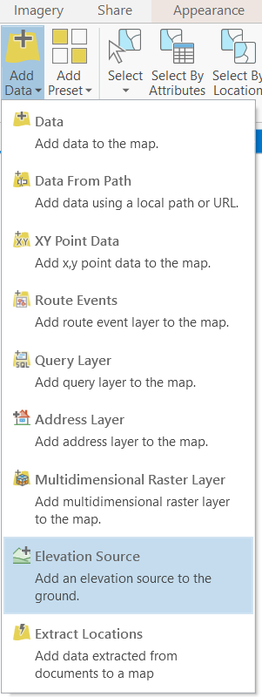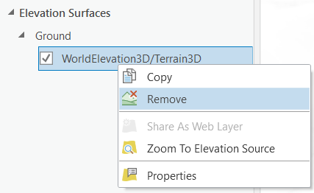

1. Next, add the same layer *DEM_50m_Zugsp.tif* as elevation layer by CLICKING on *Add Data > Elevation Source*. Now, you see the raster layer in 3D draped onto its own elevation data.

### Calculating the Slope of a DEM

Slope and aspect are calculated at each cell in the grid, by comparing the cell’s elevation to that of its eight neighbours. The slope tool identifies the gradient (slope or steepness) from each cell of a raster.

1. On the *Analysis* tab, CLICK on *Tools* to open the *Geoprocessing* pane.
2. ENTER slope into the search field of the *Geoprocessing* pane and choose **Slope** *(Spatial Analsyst Tools)*

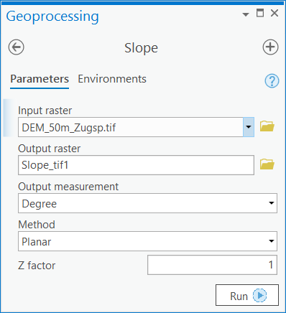

1. CHOOSE the raster data set as input raster and run the tool. The *planar Method* does not consider the curvature of the earth, but this is fine for such a small area outtake. The steepness is calculated using a 3 by 3 cell moving window over the raster input. The output will be a raster with pixel values stretching from 0 to 90 degrees. Light-coloured areas are flat valleys and lakes. Dark-coloured areas are steep.

* The Slope tool uses a 3 by 3 window of cells to compute the value. The cells in the outermost rows and columns of the output raster will be *No Data*. This is because along the boundary of the input dataset, those cells do not have enough valid neighbours (>6).

### Showing statistics of a layer

1. RIGHT-CLICK on the *Slope* layer in the *Contents* pane and go to *Create Chart > Create Histogram.* The **Chart Properties** pane opens.

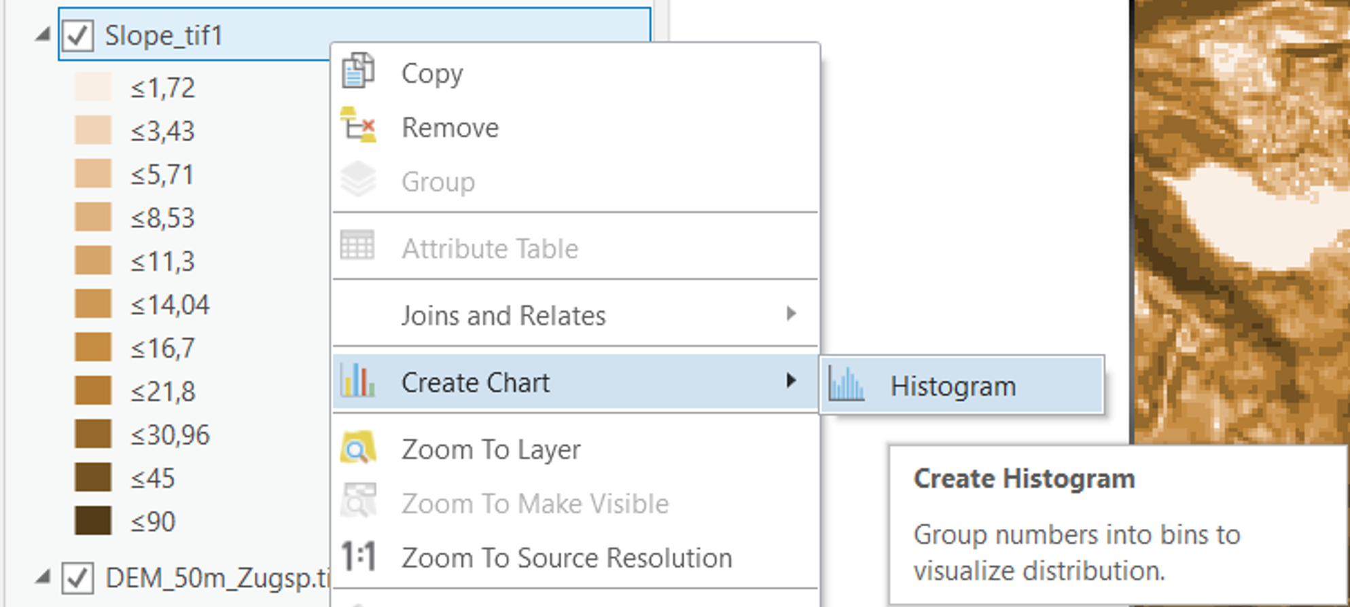

1. CHOOSE *Band_1* as the *Variable Number* with the dropdown arrow. You will receive a histogram showing the value distribution of slope values. You should be able to see that, even in this mountainous area, the flat spaces have the largest majority.

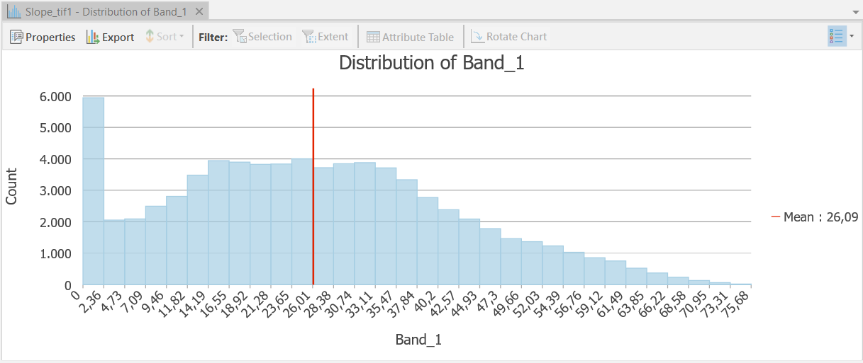

1. Further statistics and settings can be set on the *Chart Properties* pane.

### Calculating the Aspect of a DEM

The aspect refers to the horizontal direction to which the slope faces. The aspect tool uses a 3 by 3 window of cells to identify the compass direction that the downhill slope faces for each location.

1. Go back to the *Geoprocessing* pane. Search and run the ***Aspect*** tool *(Spatial Analsyst Tools).* The DEM stays as *Input raster*. The values of the output raster are the compass direction of the aspect in degrees.

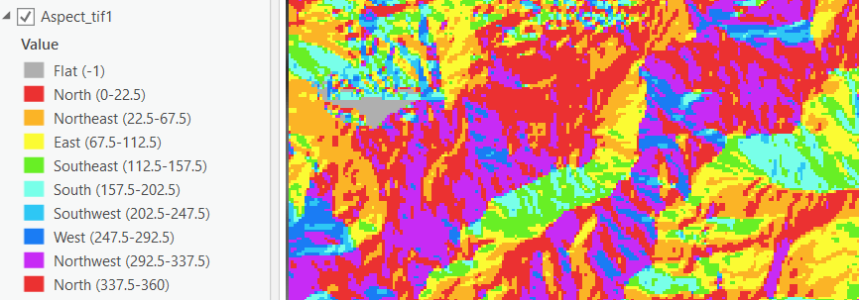

### Creating Hypsometric tints

Hypsometric tints are colours of altitude intervals to indicate elevation. These tints are shown as bands of colour in a graduated colour scheme.

1. On the *Contents* pane, deactivate the visibility of the slope and aspect layer by CLICKING on the *checkboxes*.
2. RIGHT-CLICK on the DEM layer and CLICK on *Symbology* to open the symbology pane on the right.
3. By CLICKING on the top dropdown arrow You can CHOOSE *Classify* in order to assign a specific colour to each altitude interval.
4. CHOOSE the *Equal Interval* classification *Method* to get equally sized altitude intervals.
5. CHOOSE a high number of classes and SELECT a conventional colour ramp for displaying altitude.

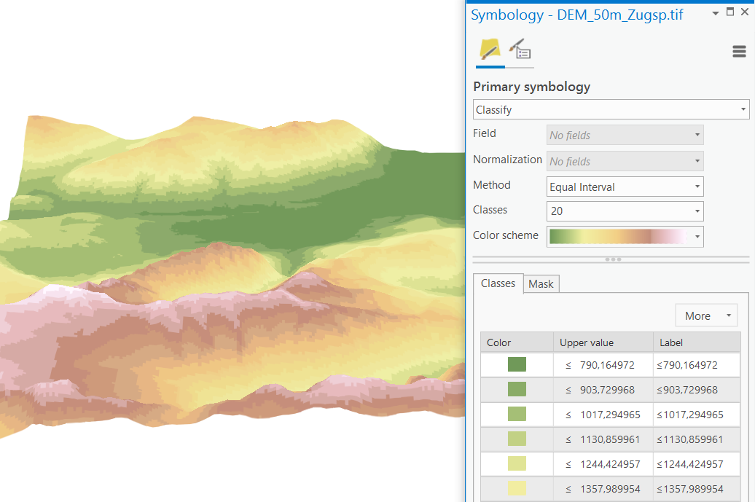

### Line-of-Sight Analysis

The Viewshed tool determines the raster surface locations visible to a set of observer features. It colours 3D faces for a surface for whether the 3D face is either visible or hidden from a specified view point. This tool is applied for the Line-of-Sight problem.

* Esri´s actual *Line of Sight* tool determines the visibility of sight lines between defined locations only.

1. Go back to the *Geoprocessing* pane. Search and run the ***Viewshed*** tool *(Spatial Analyst Tools)*
2. SELECT the DEM as input raster and Create a new input feature by CLICKING on the pencil dropdown arrow. CLICK on *Points.*

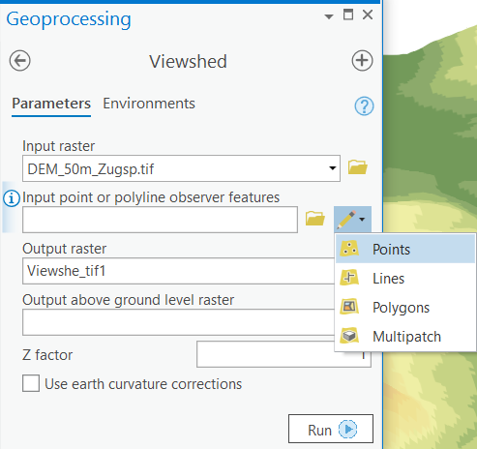

1. Create one or multiple viewshed input points by CLICKING on the DEM in the *Local Scene*.
2. CLICK on Run to execute the tool. You will create a new raster layer showing pixels of the DEM visible from the particular input point(s).

* Remember that all line-of-sight origins are at zero height. Due to the DEM´s short-wave roughness the viewsheds may appear smaller than expected.

## Hydrological Analysis

By estimating the flow distribution from all raster cells of a terrain model to its eight neighbours, the flow pattern over a drainage basin can be modelled.

* In this section we want to calculate the drainage basins based on the DEM. This has to be performed computing the flow directions and the flow accumulation as preceding steps.

### Flow Direction

One of the keys to deriving hydrologic characteristics of a surface is the ability to determine the direction of flow from every cell in the raster. The direction of flow is determined by the direction of steepest descent, or maximum drop, from each cell. The *Flow Direction* tool takes a surface as input and outputs a raster showing the direction of flow from each cell to its downslope neighbour.

1. Go back to the *Geoprocessing* pane. Search and run the ***Flow Direction*** tool *(Spatial Analyst Tools)*
2. SELECT the DEM as input raster
3. CHECK the box *Force all edge cells to flow outward.* This is done to minimize the edge effects of flow accumulation. It will lead to a better flow accumulation result.
4. CHOOSE the D8 flow option.

* The D8 flow option models flow direction from each pixel to its steepest downslope neighbour. The output of the D8 direction type is an integer raster with values for each direction from the centre. The direction coding is shown in the following image:

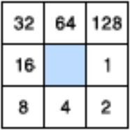

* For example, if the direction of steepest drop was to the left of the current processing pixel, its flow direction would be coded as 16. The example below shows how elevation values are converted to flow direction codes:

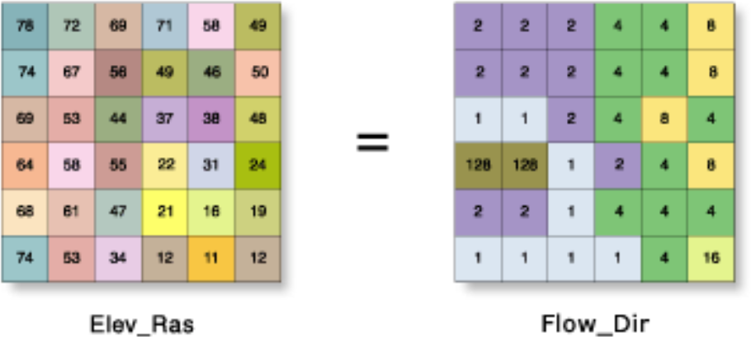

* If a pixel has the same change in elevation in multiple directions the value for that pixel in the output flow direction raster will be the sum of those directions. For example, if the change in z-value is the same to the east (flow direction = 1) and to the south (flow direction = 4), the flow direction for that pixel is 1 + 4 = 5.

1. 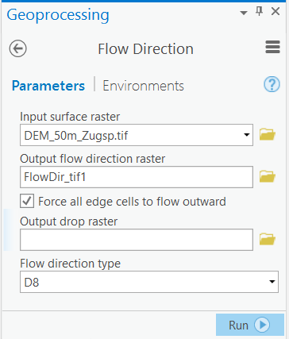CLICK on Run to execute the tool. You will create a new raster layer showing pixel values based on flow direction.

### Flow Accumulation

The [Flow Accumulation](http://pro.arcgis.com/en/pro-app/tool-reference/spatial-analyst/flow-accumulation.htm) tool calculates accumulated flow as the accumulated weight of all cells flowing into each downslope cell in the output raster. A default weight of 1 is applied to each cell (if no other weight values are inputted), and the value of cells in the output raster is the number of cells that flow into each cell. In the graphic below, the top left image shows the direction of travel from each cell and the top right the number of cells that flow into each cell.

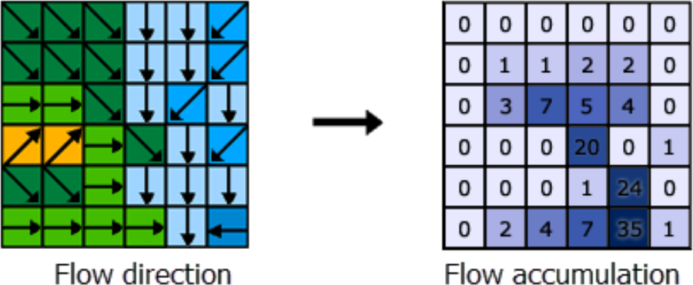

1. Go back to the *Geoprocessing* search pane. Search and run the ***Flow Accumulation*** tool *(Spatial Analyst Tools)*
2. SELECT the Flow Direction Raster File as input raster.
3. CLICK on *Run* to execute the tool. You will create a flow accumulation raster layer showing pixel values based on flow direction. Pixels with a high flow accumulation are areas of concentrated flow and may be used to identify stream channels (in Your raster layer probably in white). Pixels with a flow accumulation of 0 are local topographic highs and may be used to identify ridges.

### Drainage Basins

For this tool the drainage basins are delineated within the analysis window by identifying ridge lines between basins. The input flow direction raster is analysed to find all sets of connected cells that belong to the same drainage basin. The drainage basins are created by locating the pour points at the edges of the analysis window (where water would pour out of the raster), as well as sinks, then identifying the contributing area above each pour point. This results in a raster of drainage basins.

1. Go back to the *Geoprocessing* search pane. Search and run the ***Basin*** tool *(Spatial Analyst Tools)*
2. SELECT the Flow Direction Raster File as input raster
3. CLICK on *Run* to execute the tool. You will create a raster layer of drainage basins. All cells in the raster with the same pixel value belong to the same basin.
4. RIGHT-CLICK on the Basin layer in the *Contents* pane and CLICK on Symbology to open the symbology pane.
5. By CLICKING on the top dropdown arrow You can CHOOSE *Unique Values* in order to assign a specific colour to each basin.
6. CHOOSE a qualitative colour scheme to visualise individual drainage basins.
7. In order to mix the visualisation with the computed stream channels, SELECT the Basin Layer in the *Contents* pane and go to *Raster Later > Transparency* and decrease the opacity of the Basin with the slider tool (the Basin layer should be ordered above the flow accumulation layer).

## Cost Analysis

Cost distance tools calculate for each cell the least accumulative cost to specified source locations over a cost surface.

* In this chapter You find an optimal line for a new hiking trail between two locations, in the study area around the Zugspitze. The hiking trail should be rather easy to walk and minimise slopes. Furthermore, the new hiking trail should reduce the impact on the natural environment. Therefore, You will create a cost surface based on Your own distributed weights and calculate a least cost path for the new hiking trail.

### Reclassifying and Weighting Raster Files

A cost raster identifies the cost of traveling through each cell. To create this raster, you need to identify the cost of constructing a trail through each cell. Although the cost raster is a single dataset, it is often used to represent several criteria. In this example, land use and slope influence the construction costs. Each of these datasets is in a different measurement system (land-use type and percent slope), so they cannot be directly compared to one another and must be reclassified and weighted within a common scale.

* Here we are weighting the crucial datasets according to percent influence.

1. You can work in the same Local Scene .
2. Add the layer *LandCover.tif*. from Moodle. This is land use data from the GlobeLand30 project.
3. On the *Analysis* tab, CLICK on *Tools* to open the *Geoprocessing* pane.
4. ENTER reclassify into the search field of the *Geoprocessing* pane and choose **Reclassify** *(3D Analyst Tools) to open the tool.*
5. On the tool, CLICK on *Unique.* You see a new table with the original raster values (*Value*) and the to be edited raster Values *New.*

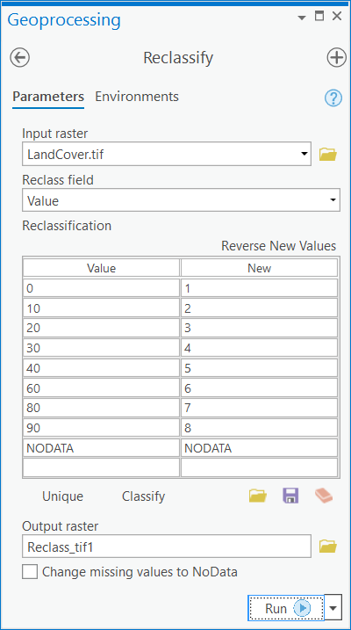

1. See the following table for an explanation of the given GlobeLand30 land cover classes (*Value*):

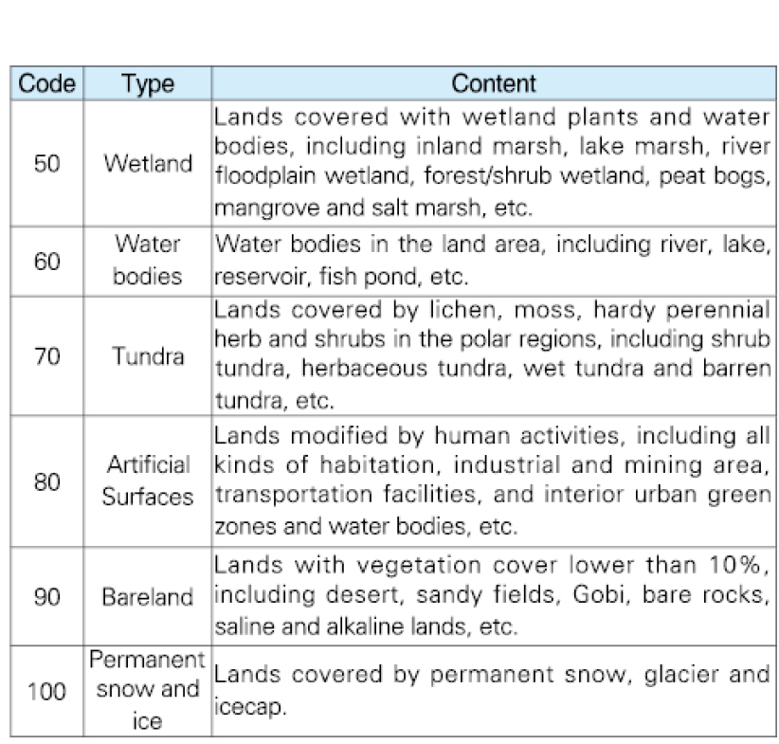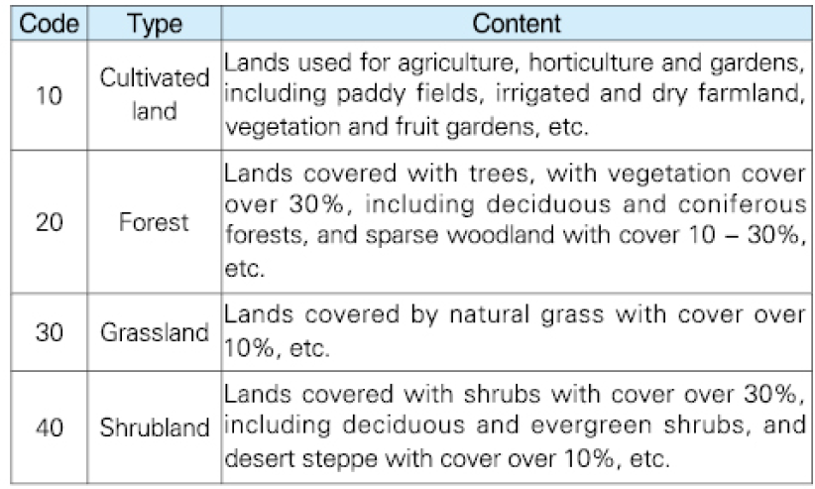

1. Think about a possible weighting scheme to reduce the hiking trail´s impact on the natural environment. Assign values in a scheme between a minimum 1 and a maximum 100

* We try to make here the weights comparable to the slopes. Take in mind that the slope layer has a mean value of 26 and a max. value of 77 ).

1. To assign the new weights, simply *doubleclick* onto the numbers in the *New* column and type the new weights (between 1 and 100).
2. CLICK **Run** to execute the tool and define the new weights in a new output raster.

* If You choose, you can adapt the raster values of the slope layer, too.

### Combining Raster Datasets to a Cost Surface

The next step in producing the cost raster is to combine the reclassified datasets. The simplest approach is to just mathematically add them together.

* The final cost raster is created by adding together the weighted datasets. It is the result of the reclassified input datasets of slope and land use.

1. ENTER plus into the search field of the **Geoprocessing** pane and choose *Plus* (3D Analyst Tools) to open the tool. This tool adds (sums) the values of two rasters on a cell-by-cell basis.
2. Choose the two input raster sets of the weighted slope and land use layers.
3. Choose a output raster data name and file path
4. CLICK *Run* to receive the cost surface.

### Calculating a Least Cost Path

The least accumulative cost distance is calculated for each cell over a cost surface, to the nearest source. This produces an output raster that records the least-cost path, or paths, from selected locations to the closest source cells defined within the accumulative cost surface, in terms of cost distance.

* Before we can calculate a least cost path based we need to change the local *Scene* coordinate system to match the coordinate system of the Cost Surface.
* Then, calculate a least cost path based on Your cost surface and two arbitrary points.

1. RIGHTCLICK onto *Scene* on the contents pane and open the **Properties**. CLICK on *Coordinate Systems*.
2. CLICK to select the coordinate system *WGS 1984 UTM Zone 32N*. You will find it by extending the *Layers* dropdown arrow on the *XY Coordinate Systems Available* field. OK to confirm. The map window will refresh to show the geodata in the new coordinate system.
3. To start the least cost path analysis, ENTER least cost into the search field of the **Geoprocessing** pane and choose *Least Cost Path* (Intelligence Tools) to open the tool. This tool calculates the least-cost path from a source to a destination
4. Choose Your individual cost surface layer as *Input Cost Surface*.
5. Create a new input feature by CLICKING on the pencil dropdown arrow next to *Input Starting Point*. CLICK on *Points.*
6. Create one *Input Starting Point* by CLICKING in the *Local Scene*.
7. Repeat the same workflow to create a *Input Ending Point*
8. Choose a *output feature class* name and file path
9. Leave the *Zero Cost Handled* option on *Small positive.* Then, all zeros will be changed to a small positive value. This will allow these (no data) cells to be traversed.
10. CLICK *Run* to execute and receive the least cost path. The least cost path is added to the scene as a polyline layer.

Contents

7. Lesson 7 – Vertical and Hydrological Analysis 1

7.1 Task Information 1

7.2 Vertical Analysis 1

7.2.1 Changing the elevation source 1

7.2.2 Calculating the Slope of a DEM 3

7.2.3 Showing statistics of a layer 3

7.2.4 Calculating the Aspect of a DEM 4

7.2.5 Creating Hypsometric tints 5

7.2.6 Line-of-Sight Analysis 6

7.3 Hydrological Analysis 7

7.3.1 Flow Direction 7

7.3.2 Flow Accumulation 8

7.3.3 Drainage Basins 9

7.4 Cost Analysis 9

7.4.1 Reclassifying and Weighting Raster Files 10

7.4.2 Combining Raster Datasets to a Cost Surface 12

7.4.3 Calculating a Least Cost Path 12